Melani Sintsova  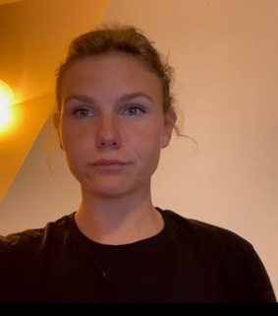  E-Mail:  msintsov@lion.lmu.edu  Phone:  +1(310)754-0000    Major: Journalism  MINORS:SCREENWRITING, PHILOSOPHY  SKILLS:  Communication, risk taking, inventive and creative mind, succinct expression.  LANGUAGES:  Fluent: Russian, English, French  In Progress: Spanish, Estonian, Latin,  Mandarin, Italian, Arabic |  | Experience  1.School YearBook:  2016-2020  2.School NewsPaper:  2018-2020  3.Organizer of activity board  2020  Education  Moscow School №18 (with a focus in English )2008-2015  International School of Monaco (with a bilingual diploma) 2015-2020  Loyola Marymount University 2020-(expected graduation year 2023)  Certificate of completion of a journalism course by Vladimir Pozner (American, French and Russian journalist)  Volunteer Experience or Leadership  Volunteer: retirement house, single mothers’ house, Red Cross, Vietnam(travelled there), Romania (collected clothes and books), Nigeria(raised money for a new school), organizing concerts and events in ISM, raising money for homeless dogs, cleaning beaches and ocean. Helping to create RedBox Project in Monaco, Organizer of anti-bullying week in ISM, Part of SheCanHeCan organization, Student ambassador at LMU, Ambassador for international students at LMU.  Internship: Investment & Development, Hostess and Financial position in the beauty salon, Editor in Russian Roulette, Writer for Saint Barth Magazine.  Hobby: dance, singing, songwriting, horse riding, piano, boxing, yoga, pilates, running, hiking, tennis, scuba-diving, pro healthy food supporter.  Jobs: teaching Russian, walking dogs, 2018 yacht show in Cannes, 2019 yacht show in Monaco, 2019/2020 organizing Instagram for the RedBoxProject in Monaco, 2017-2020 school newspaper writer-editor, 2020 Adviser for Canados yachts Instagram. Writer and reporter for LMU YearBook 2021

